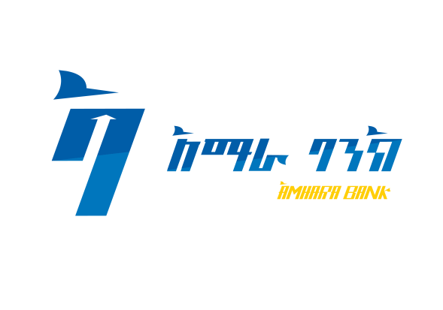

**Amhara Bank S.C**

**INVITATION TO LOCAL COMPETITIVE BIDDING**

**Bid Ref. No. ABa/NCB/064/2023**

Amhara Bank S.C. (ABa) invites sealed bids from eligible bidders for the procurement of the following items and service.

|  |  |  |
| --- | --- | --- |
| **Lots** | **Items Description** | **Bid Security Amount Birr** |
| **Lot - 01** | Microsoft 365 Enterprise License Renewal | 50,000.00 |
| **Lot - 02** | Oracle Audit Vault & Database Firewall | 50,000.00 |

**Bidding Requirements:**

1. Bidding document will be conducted through National Competitive Bidding (NCB) procedures contained in the Amhara Bank S.C. and are open to all eligible bidders. Interested eligible bidders may obtain further information from Procurement & Facilities Management Department.
2. The bid document shall be obtained commencing October 18, 2023 from Procurement Division, cited at Amhara Bank S.C, Procurement & facility Directorate, Around Leghar, Ras Mekonnen Street, ORDA Tower 20th Floor against payment of a non-refundable fee of Birr 200.00 (Two Hundred Birr Only) for each lot during office hours by **depositing at Amhara Bank S.C, Addis Ababa Branch Head office Ground floor during office hours.**
3. Bidders must present professional license, Tax clearance certificate and VAT registration certificate.
4. Tenders must be supported with bid Bond (Re-fundable) in shape of CPO or unconditional Bank Guarantee in favor of Amhara Bank S.C. as per the above Bid Security Amount.
5. All bids must be deposited in the tender box prepared for this purpose at Procurement Division, cited at Amhara Bank S.C, HO Procurement & Facility Management Director.
6. Bids will be opened in the presence of the bidders/representatives who choose to attend in person at the address below as per the following schedule.

|  |  |  |
| --- | --- | --- |
| **Lot** | **Closing Date & Time** | **Opening Date & Time** |
| Lot 1 | November 02, 2023 at 10:00 A.M | November 02, 2023 at 10:30 A.M |
| Lot 2 | November 02, 2023 at 2:00 P.M | November 02, 2023 at 2:30 P.M |

1. Interested eligible bidders may obtain further information from the office of Procurement Division Tell. +251-11-558-29-05
2. The Bank reserves the right to accept or reject any or all bids.

**Amhara Bank S.C**